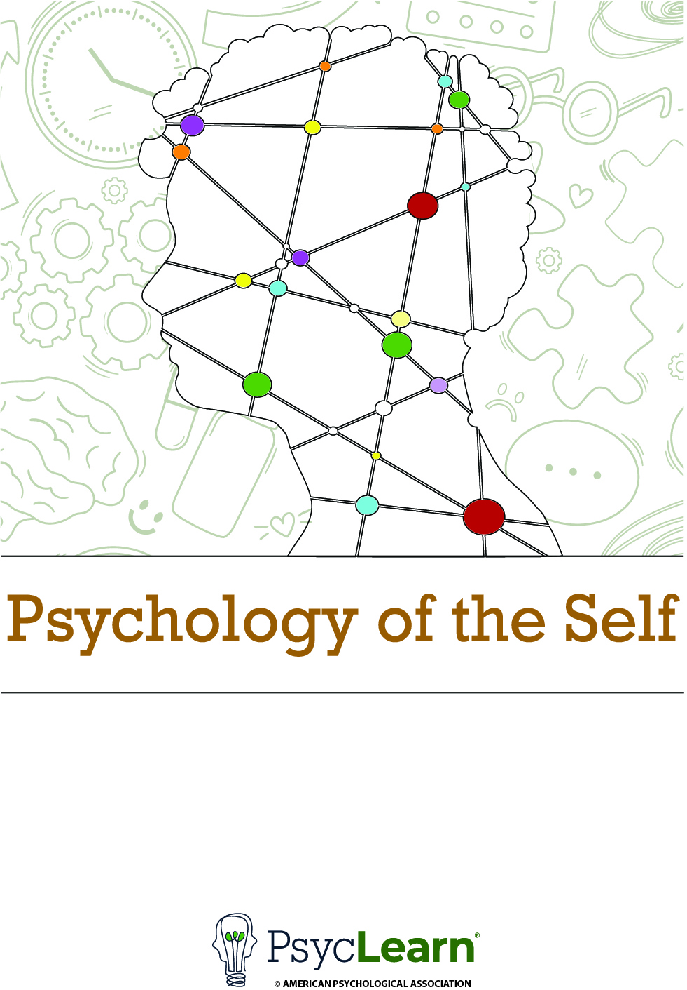

Workbook

for

Psychology of the Self

Discover Yourself, Build Relationships, and Navigate Groups Specialization

American Psychological Association

© 2024 by American Psychological Association
All rights reserved.

No part of this document or the related files may be reproduced or transmitted in any form, by any means (electronic, photocopying, recording, or otherwise) without the prior written permission of the publisher.

American Psychological Association
750 First Street, NE
Washington, DC 20002-4242
www.apa.org

Welcome to the Workbook for the Psychology of the Self course!

This workbook, included with a subscription to the American Psychological Association’s Discover Yourself, Build Relationships, and Navigate Groups specialization, is designed to deepen your understanding and enhance your knowledge of the content presented in the Psychology of the Self course. Drawing from real-world psychological surveys and applying the results of scientific studies, the activities in the workbook offer the opportunity to put research into practice and apply the course concepts to your everyday life.
Having downloaded this document, you now have access to all of the workbook activities in the course. As you proceed through each of the five content modules of the course, you will encounter prompts to open your workbook and complete each activity. These prompts will be labeled with the word “Activity” and will be followed by the title of the activity, a short written description of the activity, and an audio file that provides instructions for how to complete the activity. The activity titles in Coursera correspond exactly to the activity titles in this workbook.
As you complete each activity, be sure to save your work in an easy-to-locate place. In several activities, you will be asked to reflect upon your past work. Engaging in reflection will allow you to observe how your understanding of the self in general and your understanding of your own self both evolve as you complete each module of the course.
We hope you enjoy using this workbook as much as we enjoyed making it.

Table of Contents
Module 1: Introducing the “I Am” Task 6
Module 2: Diagram Your Self-Concept 8
Module 2: Examining Your Self-Concept 9
Module 2: Revisiting the “I Am” Task 10
Module 2: The Self-Construal Scale 12
Module 2: The Self-Monitoring Scale 15
Module 3: Reflecting on Self-Enhancement 18
Module 3: Reflecting on Self-Verification 20
Module 3: Reflecting on Accuracy 22
Module 4: The Rosenberg Self-Esteem Scale 24
Module 5: Reflecting on Self-Regulation 26
Module 5: Considering Barriers to Self-Regulation 28
Module 5: Help Your Friend Self-Regulate 30
References 32

Module 1: Introducing the “I Am” Task

Instructions

Part 1 Instructions
Complete each of the sentences below to create a true statement about yourself. Then, after you’ve finished, read the instructions for Part 2.
Example: I am an architect.

List of “I Am” Statements
Stable Role/Group
- I am _________________________________________. 
- I am _________________________________________.
- I am _________________________________________.
- I am _________________________________________.
- I am _________________________________________.
- I am _________________________________________.
- I am _________________________________________.
- I am _________________________________________.
- I am _________________________________________.
- I am _________________________________________.

Part 2 Instructions
For each of the completed statements above, put a check mark in the box in the column labeled “Stable” if that sentence is unlikely to change over time. For example, the statement “I am Pakistani” should have a check mark in the box under “Stable.” Once you’re done with the “Stable” column, go back through and put a check mark in each box in the “Role / Group” column if the statement in that row represents a role you take (such as being a parent or a police officer) or a group to which you belong (such as a political party or a sports team).
Notice that not every row needs to have one or both boxes checked. For example, the statement “I am tired” isn’t stable, nor is it a role you take or a group to which you belong. Finally, we will be referring to your answers later in the course, so make sure you have them saved somewhere accessible.

Adapted from "An empirical investigation of self-attitudes," by M. H. Kuhn & T. S. McPartland, 1954, American Sociological Review, 19, pp. 68–76 (https://doi.org/10.2307/2088175). Copyright 1954 by American Sociological Association.

Module 2: Diagram Your Self-Concept

Instructions
This is a diagram of a part of your self-concept. The circle at the center labeled “Me” represents your concept of yourself. Each of the five outer circles has a line going to the center circle labeled “Me” to indicate that these concepts are associated with your mental representation of yourself. Fill in each outer circle with a word or short phrase that you believe to be self-descriptive. These could be words that you listed in your “I Am” task previously, or they could be descriptors that you’re coming up with right now. Please make sure that at least one of the outer circles is filled in with either a role that you have (e.g., your profession) or a group to which you belong (e.g., your religion).

Diagram Your Self-Concept Activity

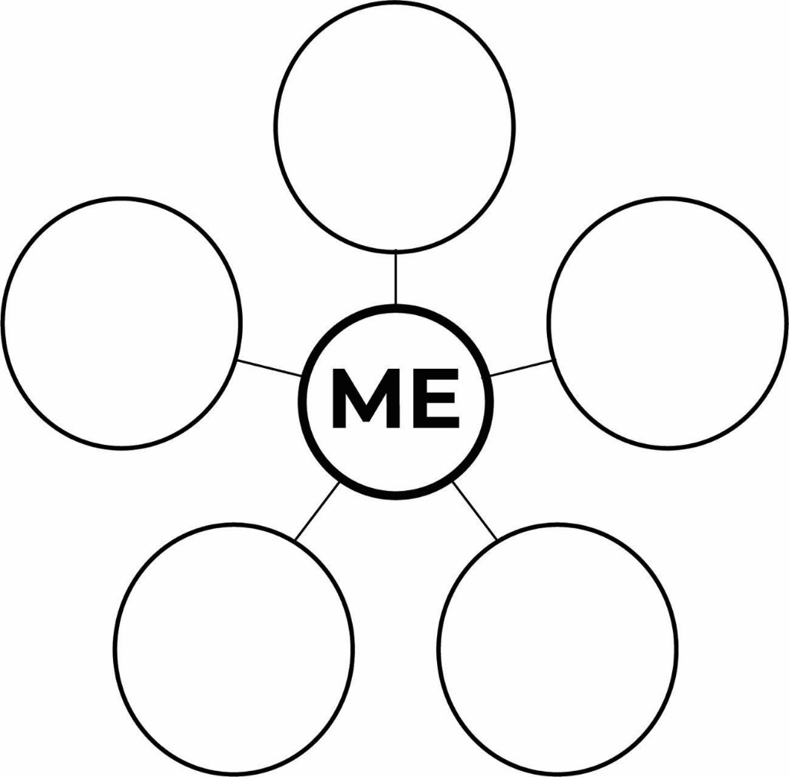

Module 2: Examining Your Self-Concept

Instructions
Think of a role you have or a group you belong to. (Looking back at your answers to the “I Am” task in Module 1 could help with this.) Write that word or words in the circle directly connected to “Me.” Then, think of four ideas associated with that role or group that you also see in yourself. Write each of these ideas in one of the four bubbles connected to your role/group circle. If any of these four bubbles relate to one another, draw lines between the related bubbles.
When you’ve finished, return to the Coursera page to read some final comments.

Examining Your Self-Concept Activity

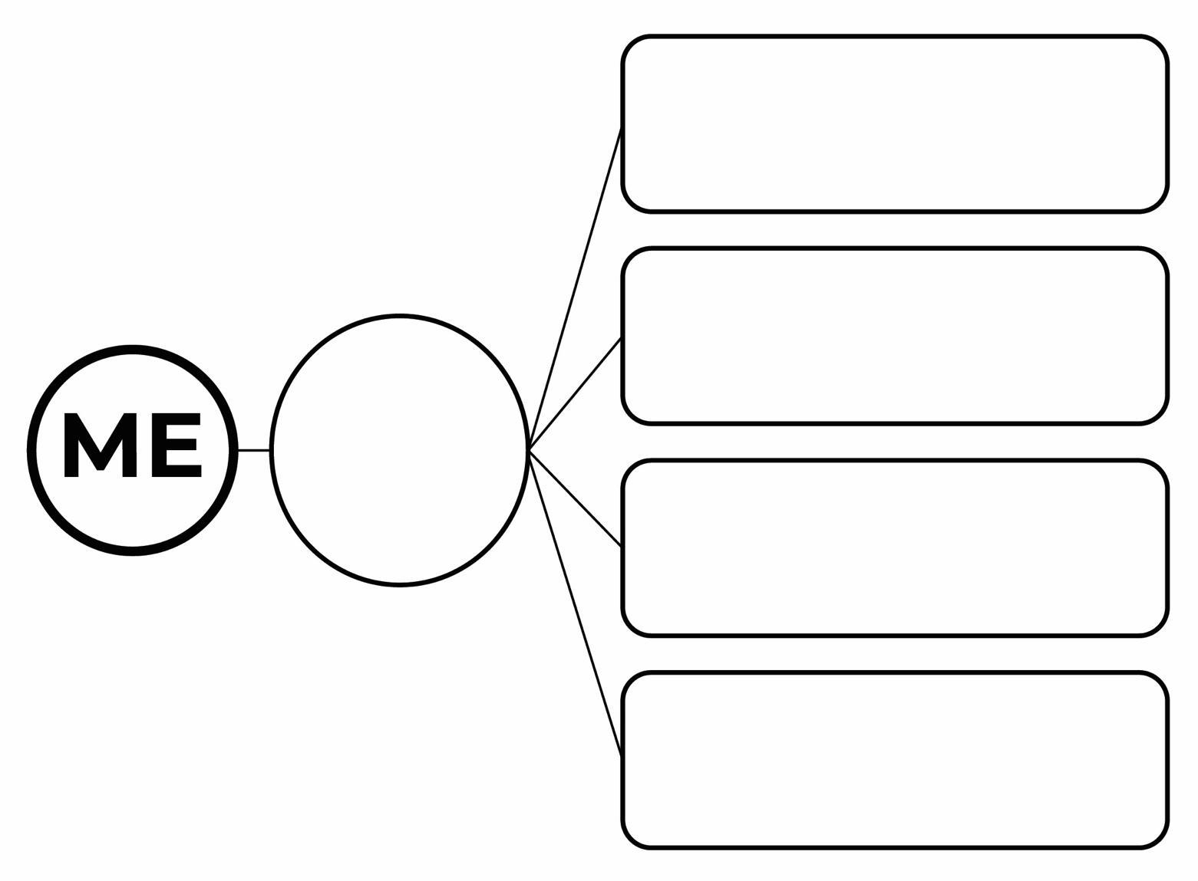

Module 2: Revisiting the “I Am” Task

You may recall that you completed the “I Am” task previously, in the activity called Introducing the “I Am” Task. We would like you to revisit the task now. Do not refer to your original answers before completing this activity.

Instructions

Part 1 Instructions
Complete each of the sentences on the following blank lines to create a true statement about yourself. Then, after you’ve finished, read the instructions for Part 2.

- I am_________________________________________.
- I am _________________________________________.
- I am _________________________________________.
- I am _________________________________________.
- I am _________________________________________.
- I am _________________________________________.
- I am _________________________________________.
- I am _________________________________________.
- I am _________________________________________.
- I am _________________________________________.

Part 2 Instructions
Now that you’ve completed your “I Am” task, go back and review your answers from the previous time you did this activity, on the workbook page titled Introducing the “I Am” Task. Do your answers from the two versions of the “I Am” task match? Was there no overlap at all? Were some of your responses the same and some different?

In the following box, write a few sentences describing how similar your responses were the two different times you completed this activity. Then, write a sentence or two about why you think your responses were similar or different between the activities.

Write your sentences in this text box.

When you have finished writing about your responses, return to the Coursera page and continue reading.

Adapted from "An empirical investigation of self-attitudes," by M. H. Kuhn & T. S. McPartland, 1954, American Sociological Review, 19, pp. 68–76 (https://doi.org/10.2307/2088175). Copyright 1954 by American Sociological Association.

Module 2: The Self-Construal Scale

Instructions

Part 1 Instructions
In this activity, you will complete a survey called the Self-Construal Scale. This survey contains thirty statements. Your task is to decide how much you agree or disagree with each statement and indicate that with a number between 1 (strongly disagree) and 7 (strongly agree). Once you finish responding to each statement, we will walk you through calculating and interpreting your results.
For each of the following statements, use the seven-point scale below to indicate how strongly you agree or disagree. Write your response in the blank space to the left of each numbered statement. Do not leave any statement blank. After you’ve responded to the last statement, continue on to Part 2.
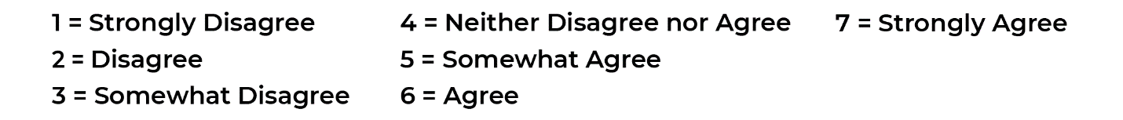

Statements

____1. I enjoy being unique and different from others in many respects.
____2. I can talk openly with a person who I meet for the first time, even when this person is much older than I am.
____3. Even when I strongly disagree with group members, I avoid an argument.
____4. I have respect for the authority figures with whom I interact.
____5. I do my own thing, regardless of what others think.
____6. I respect people who are modest about themselves.
____7. I feel it is important for me to act as an independent person.
____8. I will sacrifice my self-interest for the benefit of the group I am in.
____9. I'd rather say "No" directly, than risk being misunderstood.
____10. Having a lively imagination is important to me.
____11. I should take into consideration my parents' advice when making education/career plans.
____12. I feel my fate is intertwined with the fate of those around me.
____13. I prefer to be direct and forthright when dealing with people I've just met.
____14. I feel good when I cooperate with others.
____15. I am comfortable with being singled out for praise or rewards.
____16. If my brother or sister fails, I feel responsible.
____17. I often have the feeling that my relationships with others are more important than my own accomplishments.
____18. Speaking up during a class (or a meeting) is not a problem for me.
____19. I would offer my seat in a bus to my professor (or my boss).
____20. I act the same way no matter who I am with.
____21. My happiness depends on the happiness of those around me.
____22. I value being in good health above everything.
____23. I will stay in a group if they need me, even when I am not happy with the group.
____24. I try to do what is best for me, regardless of how that might affect others.
____25. Being able to take care of myself is a primary concern for me.
____26. It is important to me to respect decisions made by the group.
____27. My personal identity, independent of others, is very important to me.
____28. It is important for me to maintain harmony within my group.
____29. I act the same way at home that I do at school (or work).
____30. I usually go along with what others want to do, even when I would rather do something different.

Part 2 Instructions
Now it is time for you to generate 2 scores for this scale. Higher or lower scores on the scale aren’t better or worse. Each score you get will help you understand how your self-concept is structured and how this structure impacts how you view the world.
Half of the statements on this survey assess the extent to which you represent yourself as an independent person. That is, they measure to what extent you define yourself based on your own attributes. The other half of the scale assesses the extent to which you represent yourself as an interdependent person. That is, they measure to what extent you define yourself based on your relationships with other people. Again, neither of these self-construals is better than the other. They are simply two different ways of perceiving the world.

Independence Score
For this score, you will add up your responses to the statements that assess independent self-construal and divide that sum by 15 to give you an average score for independent self-construal.
Add up your responses to the following statements:
1, 2, 5, 7, 9, 10, 13, 15, 18, 20, 22, 24, 25, 27, and 29
Then, divide that sum by 15 and write the result on the line below.
Independent Self-Construal Score: ________

Interdependence Score
For this score, you will add up your responses to the statements that assess interdependent self-construal and divide that sum by 15 to give you an average score for interdependent self-construal.
Add up your responses to the following statements:
3, 4, 6, 8, 11, 12, 14, 16, 17, 19, 21, 23, 26, 28, and 30
Then, divide that sum by 15 and write the result on the line below.
Interdependent Self-Construal Score: ________
Now that you have your scores, you can return to the Coursera reading page.

From “The Measurement of Independent and Interdependent Self-Construals,” by T. M. Singelis, 1994, Personality and Social Psychology Bulletin, 20(5), p. 585 (https://doi.org/10.1177/0146167294205014). Reprinted with permission.

Module 2: The Self-Monitoring Scale

Instructions

Part 1 Instructions
In this activity, you will complete a survey called the Self-Monitoring Scale. This survey contains eighteen statements. Your task is to decide whether these statements are true or false about you. Once you finish responding to each statement, we will walk you through calculating and interpreting your results.
For each of the following statements, write T or F in the blank space to the left of each numbered statement to indicate whether this statement is true for you most of the time or false for you most of the time. Make sure you respond to each statement. For now, leave the blank spaces labeled “Score” empty. After you’ve responded to the last statement, continue on to Part 2.

True or False Statements

___ 1. I find it hard to imitate the behavior of other people. Score: ____
___ 2. At parties and social gatherings, I do not attempt to do or say
things that others will like. Score: ____

___ 3. I can only argue for ideas which I already believe. Score: ____
___ 4. I can make impromptu speeches even on topics about which
I have almost no information. Score: ____

___ 5. I guess I put on a show to impress or entertain others. Score: ____
___ 6. I would probably make a good actor. Score: ____
___ 7. In a group of people I am rarely the center of attention. Score: ____
___ 8. In different situations and with different people, I often act like
very different persons. Score: ____

___ 9. I am not particularly good at making other people like me. Score: ____
___ 10. I'm not always the person I appear to be. Score: ____

___ 11. I would not change my opinions (or the way I do things) in
order to please someone or win their favor. Score: ____

___ 12. I have considered being an entertainer. Score: ____
___ 13. I have never been good at games like charades or
improvisational acting. Score: ____

___ 14. I have trouble changing my behavior to suit different people
and different situations. Score: ____
___ 15. At a party I let others keep the jokes and stories going. Score: ____
___ 16. I feel a bit awkward in public and do not show up quite as well
as I should. Score: ____

___ 17. I can look anyone in the eye and tell a lie with a straight face
(if for a right end). Score: ____

___ 18. I may deceive people by being friendly when I really
dislike them. Score: ____

Part 2 Instructions
Now it is time for you to score your answers to this scale.
We are going to give you an answer to each of the 18 statements. These aren’t right or wrong answers, and higher or lower scores aren’t better or worse on this scale; they just describe different styles of interacting with the world. If your answer matches the one we give you, write 1 in the blank space labeled “Score” to the right of each statement. If your answer doesn’t match the one we give you, write 0 in the blank space labeled “Score” next to the statement.
Give yourself a point for each statement where your answer matches the following answer:
- F
- F
- F
- T
- T
- T
- F
- T
- F
- T
- F
- T
- F
- F
- F
- F
- T
- T
Once you have a score for each statement, add up all of the points. That is your total score for the Self-Monitoring Scale. You can write it below for easy reference.
Self-Monitoring Scale Score: __________
Now that you have your score, you can return to the Coursera reading page.

Courtesy of Mark Snyder. From “'To carve nature at its joints': On the existence of discrete classes in personality," by M. Snyder and S. Gangestad, 1985, Psychological Review, 92(3), pp. 317–349. (https://doi.org/10.1037/0033-295X.92.3.317). Reprinted with permission.

Module 3: Reflecting on Self-Enhancement

Instructions
Answer each of the following questions in one to three sentences. For each question, stop and think for a minute or two before answering it to make sure you’re picking a situation that matches what the question is asking for.

Questions
- Describe a time in your life when someone asked for your feedback and, in retrospect, it became clear to you that they had wanted you to give them enhancing (positive) feedback rather than accurate feedback.
Write your response to question 1 in this text box.

- Describe a situation in which someone other than you demonstrated one or more of the three positive illusions listed in this module. Refer back to the self-enhancement page, if necessary.
Write your response to question 2 in this text box.

- It’s often easier to recognize these behaviors and the biases that they generate in others than it is to recognize them in yourself. Next, reflect on the same questions applied to you. Describe a time when you went to someone seeking positive information about yourself even though you knew the positive information you would receive was not necessarily accurate.
Write your response to question 3 in this text box.

- Describe one of the positive illusions listed in this module that you see in yourself.
Write your response to question 4 in this text box.

Module 3: Reflecting on Self-Verification

Instructions
Answer each of the following questions in one to three sentences. For each question, stop and think for a minute or two before answering it to make sure you’re picking a situation that matches what the question is asking for.

Questions
- Describe a time in your life when someone asked for your opinion and, in retrospect, it became clear to you that they had wanted you to confirm their opinion about themselves. For example, your friend who thinks they are funny might have asked you to give them feedback on a joke they wrote.
Write your response to question 1 in this text box.

- In the situation you just described, did you react as your friend wanted you to? What was their reaction to your feedback?
Write your response to question 2 in this text box.

- As with self-enhancement, it’s often easier to recognize these motives in others than it is to recognize them in yourself. So, it’s time again to reflect on these questions applied to you. Describe a time in your life when you went to someone seeking confirmation about your view of yourself, regardless of whether it was accurate or not.

Write your response to question 3 in this text box.

- Now, think of a time you sought verifying feedback, but didn’t receive it. How did you react internally (e.g., emotionally) and externally (i.e., behaviorally)?

Write your response to question 4 in this text box.

Module 3: Reflecting on Accuracy

Instructions
Answer each of the following questions in one to three sentences. For each question, stop and think for a minute or two before answering it to make sure you’re picking a situation that matches what the question is asking for.

Question
- Reflect on a time when you sought feedback from others in a way that would satisfy an accuracy motive. Now, specifically describe a time when you sought accurate feedback from someone despite knowing that the feedback was likely to be negative.
Write your response to question 1 in this text box.

- Why, in the situation you just described, did you choose to seek out accurate feedback as opposed to self-enhancing feedback?
Write your response to question 2 in this text box.

- Did the situation match up well with the material we covered, suggesting that people seek accurate feedback particularly when (a) succeeding in a situation is important to them and (b) the likelihood of success is changeable based on the feedback you receive? If so, how? If not, why do you think you sought accurate feedback in this situation?

Write your response to question 3 in this text box.

Module 4: The Rosenberg Self-Esteem Scale

Instructions
Part 1 Instructions
In this activity, you will complete a survey called The Rosenberg Self-Esteem Scale. The survey contains 10 statements that address general feelings about yourself. Using the 4-point scale that follows, indicate how strongly you agree or disagree with each statement by writing a number in the blank to the left of each statement.
After you’ve responded to the last statement, continue on to Part 2.
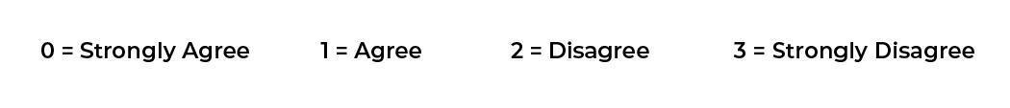

Statements
____1. I feel that I am a person of worth, at least on an equal plane with others.
____2. I feel that I have a number of good qualities.
____3. All in all, I am inclined to feel that I am a failure.
____4. I am able to do things as well as most other people.
____5. I feel I do not have much to be proud of.
____6. I take a positive attitude toward myself.
____7. On the whole, I am satisfied with myself.
____8. I wish I could have more respect for myself.
____9. I certainly feel useless at times.
____10. At times I think I am no good at all.

Part 2 Instructions
Some of these statements are written so that agreement indicates high self-esteem, and others are written so that disagreement indicates high self-esteem. To get a total self-esteem score for all of the questions, we need to recalculate some of your answers.
For statements 1, 2, 4, 6, and 7, convert your scores as follows:
If you answered 0 (strongly agree), convert that answer to a 3.
If you answered 1 (agree), convert that answer to a 2.
If you answered 2 (disagree), convert that score to a 1.
If you answered 3 (strongly disagree), convert that score to a 0.
For the other items, leave the scores as they are. Then, add up all of your scores and write the result in the space labeled “Total Self-Esteem Score.”
Total Self-Esteem Score: __________
When you’ve finished, return to the Coursera page to learn how to interpret your score.

From Society and the Adolescent Self-image, by M. Rosenberg, 1989 (Rev. ed.). Wesleyan University Press. (https://socy.umd.edu/about-us/rosenberg-self-esteem-scale). In the public domain.

Module 5: Reflecting on Self-Regulation

Instructions
Answer each of the following questions in one to three sentences. Before answering each question, stop and reflect for a moment on what you’ve learned about self-regulation so far.

Questions
- Describe a situation from your personal life (e.g., interactions with friends or family) when you successfully performed self-regulation. That is, describe a situation where you had to control or change your thoughts, feelings, or behaviors to achieve a goal (e.g., succeeding in getting something that you wanted, such as a positive interaction).

Write your response to question 1 in this text box.

- In the scenario you just described, what would have happened if you had failed to successfully self-regulate? Consider both your emotional reactions to the failure and others’ reactions toward you.

Write your response to question 2 in this text box.

- Now, describe a situation from your personal life when you were unsuccessful in trying to self-regulate (e.g., trying to exercise on a regular schedule, but failing).

Write your response to question 3 in this text box.

- In the scenario you just described, what, if anything, could you have done differently in order to self-regulate?

Write your response to question 4 in this text box.

Module 5: Considering Barriers to Self-Regulation

Instructions
This activity will ask you to consider a specific goal in the context of what you’ve learned about self-regulation. Answer each of the following questions in one to three sentences. Before answering each question, stop and think for a minute or two about what you know about self-regulation so far.

Questions

- Describe a goal that you are interested in pursuing. Be as specific as possible in describing what you would like to achieve.

Write your response to question 1 in this text box.

- Describe why you’re motivated to reach this goal.

Write your response to question 2 in this text box.

- What factor or factors might, at least temporarily, decrease your motivation to achieve your goal?

Write your response to question 3 in this text box.

- Describe two factors (either physical or psychological) that could limit your ability to achieve this goal.

Write your response to question 4 in this text box.

Module 5: Help Your Friend Self-Regulate

Instructions
Read the scenario. Then, answer each of the questions that follows in one to three sentences.

Scenario
Many people set New Year’s resolutions. One of the most popular New Year’s resolutions is to learn a new skill, such as how to play an instrument. Imagine that a close friend made the resolution to learn how to play the guitar. You know that carrying out a New Year’s resolution consistently and to completion is difficult–and perhaps even impossible–for most people. Can you help your friend beat the odds by giving them tips to improve their self-regulation?
Applying what you’ve learned about self-regulation so far, help your friend create a plan for achieving this New Year’s resolution.

Questions
- Create a specific goal that reflects your friend’s resolution to learn to play the guitar. Recall that effective goals that are easily measurable are often more achievable.

Write your response to question 1 in this text box.

- Describe two ways that your friend could monitor their behavior while they work to achieve their specific goal. Recall that the purpose of monitoring behavior is to objectively evaluate progress toward a goal, and, like the goal, should be phrased using specific measurements.

Write your response to question 2 in this text box.

- We all struggle as we try to reach our goals. One way to get over these obstacles is to create implementation intentions that will tell us what to do when we hit a roadblock. Craft two implementation intentions to support the specific goal you created for your friend. Remember that these intentions are often framed in an “if/then” format, with a specific trigger causing a specific response to occur.

Write your response to question 3 in this text box.

References

Gangestad, S., & Snyder, M. (1985). “To carve nature at its joints”: On the existence of discrete classes in personality. Psychological Review, 92(3), 317–349. https://doi.org/10.1037/0033-295X.92.3.317
Kuhn, M. H., & McPartland, T. S. (1954). An empirical investigation of self-attitudes. American Sociological Review, 19, 68–76. https://doi.org/10.2307/2088175
Rosenberg, M. (1965). Society and the adolescent self-image. Princeton University Press.
Singelis, T. M. (1994). The measurement of independent and interdependent self-construals. Personality and Social Psychology Bulletin, 20(5), 580–591. https://doi.org/10.1177/0146167294205014

